COMPUTER PROGRAMMING PROJECT


FALL 2023
GROUP INFO:
NAME: Waleed Ahmed – 01-131232-093
NAME: Amir Ali – 01-131232-011
NAME: Muhammad Saim -01-131232-065
NAME: Raja Abdul Hadi -01-131232-075
Department of Software Engineering
Bahria University h-11 Campus
POSTURE FOR PROJECT
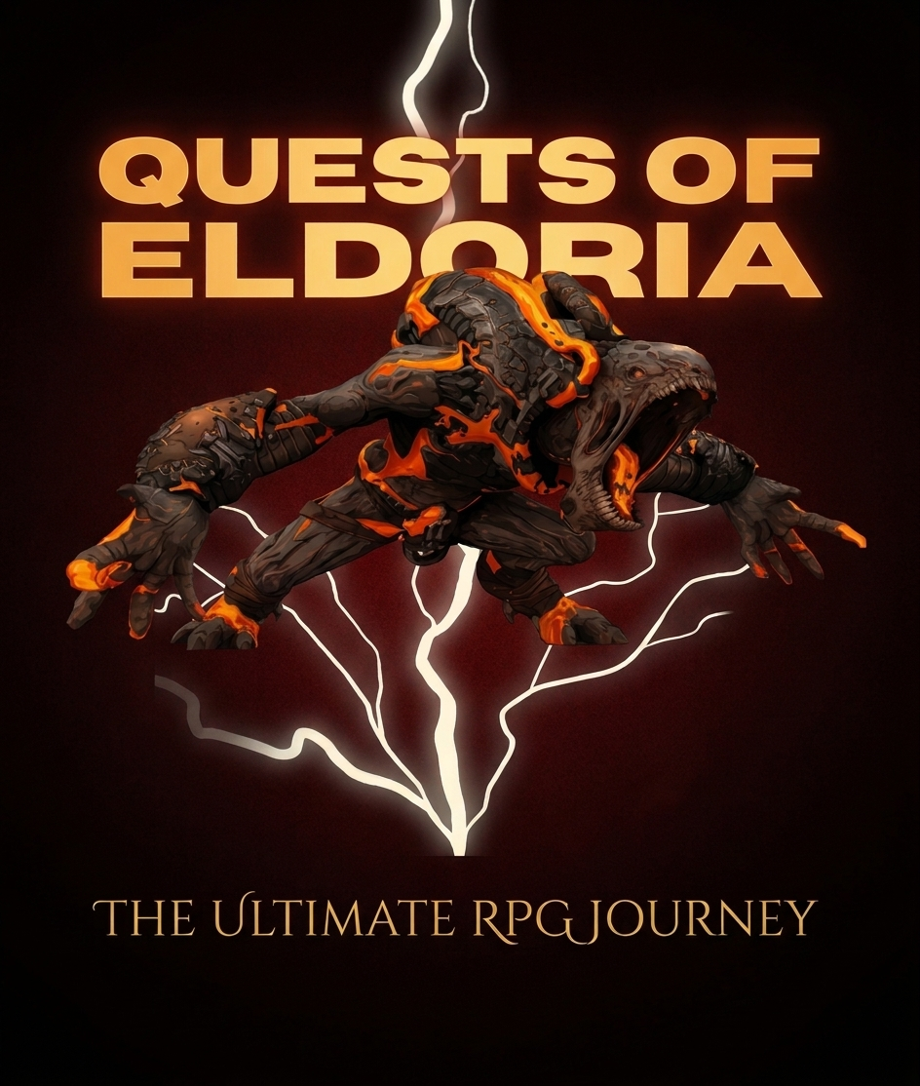
STORYLINE:
Our storyline is categorized into the following features:

Difficulty Selection:

The player is prompted to choose a difficulty level: Easy, Medium, or Hard.
The chosen difficulty level determines the strength of enemies and the number of available moves.
Gameplay:

The player engages in turn-based battles with enemies, where both the player and the enemy have health points.
The player can choose between Low (L), Medium (M), and High (H) moves during their turn.
The damage dealt by the player depends on the chosen move and is calculated using random numbers.
Enemy Levels:

Each difficulty level introduces different enemies with varying health points and damage output.
Boss enemies appear at certain levels, presenting greater challenges.
Player Progression:

The player gains experience points (exp) by defeating enemies.
After defeating an enemy, the player advances to the next level with stronger enemies.
Move Limits:

The player has a limited number of Medium and High moves based on the chosen difficulty.
Strategic move choices are essential to defeating enemies without exhausting available moves.
Game Over and Victory Conditions:

The game can end in victory if the player defeats all enemies and completes the final level.
The game ends in defeat if the player's health reaches zero before completing the final level.
Play Again Option:

After each game, the player is given the option to play again (Y/N).
Invalid inputs are handled with user prompts for correct input.
Experience Points:

The player's experience points increase with each defeated enemy.
The experience points provide a measure of the player's progress in the game.
Overall, this game provides a basic RPG experience with elements of strategy and chance. Players must choose their moves wisely and manage limited resources to progress through the levels and ultimately defeat the final boss. The game's structure encourages replayability, allowing players to attempt different difficulty levels and improve their strategic skills.
WORK EXPERIENCE:
The overall experience in doing this project is average. It was neither too bad nor too good .At first we faced so many difficulties and so many confusions occurred but we take help from the internet and from other sources and then we come to know about this project and started working. .While doing this project we find many things really easy and interesting, yet we faced so many barriers but with our consistent hard work we have made it to accomplishment .This project is really helpful for us as before this task we really don’t know about so many things but now we are aware of things in a more good way like logics ,functions ,structure and much more .
WORK DIVIDE:
Firstly we all discuss about the project and then we assign everybody a different task such as logics building etc. Basically we have not divide the work too much instead we have done it collectively so that everyone should get the knowledge properly. Minor work has been divided but the major part (the core part) has been completed collectively.

SOME SCREENSHOTS OF CODE:

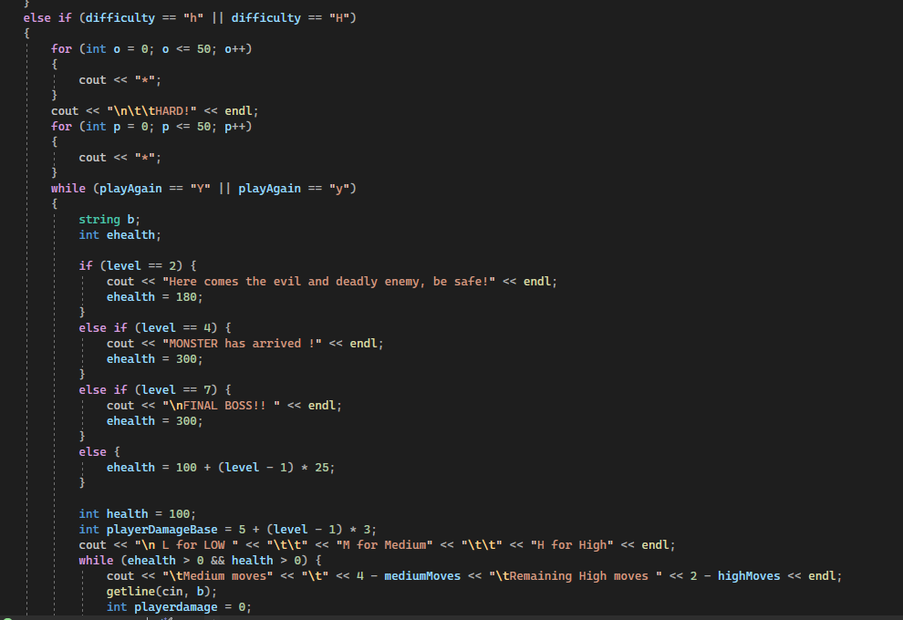
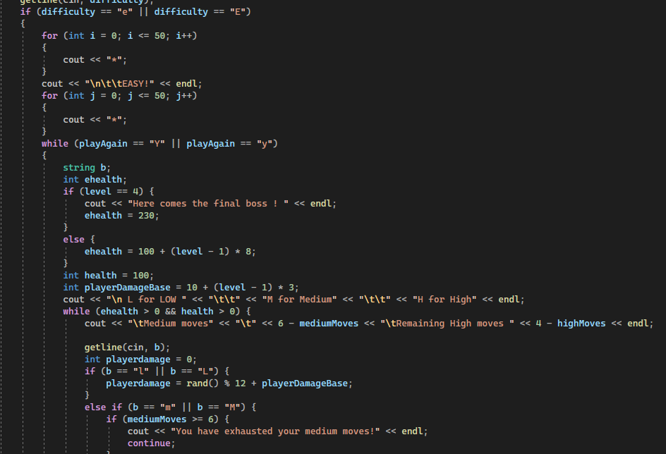

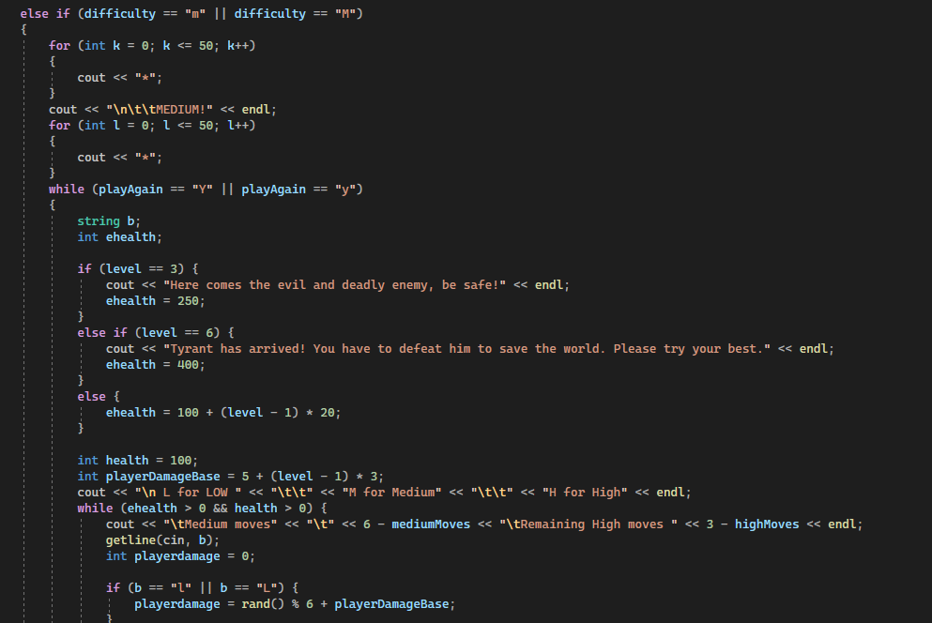
GITHUB REPOSITORY LINK:
https://github.com/WaleedAhmed10/Quests-of-Eldoria-CPProject

